**PRACTICAL: 14(Exception Handling)**

**AIM:**

**Write a program to perform Exception Handling.**

**OBJECTIVES:**

**Implement a C++ program which throws a division by zero exception and we**

**catch it in catch block.**

**Define a function name division which will take two integers as arguments and**

**returns a double value. This function should throw “division by zero error”**

**You have to write try catch block in main while calling the above function.**

**Program:**

// Exception handling

#include <iostream>

using namespace std;

double division(int a, int b);

double division(int a, int b){

if(b==0){

throw ("zero_divide_exception");

}

else return a/b;

}

int main()

{ int a,b;

cout << "Enter the 1st number :" <<endl;

cin>>a;

cout << "Enter the 2nd number :" <<endl;

cin>>b;

try{

double c= division(a,b);

cout << "The division is : "<< c<<endl;

}

catch(...){

cout<< "Error ! Divide by zero error." <<endl;

}

return 0;

}

**OUTPUT:**

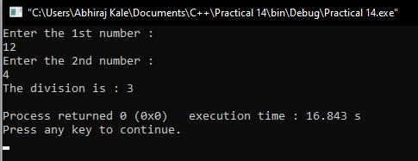

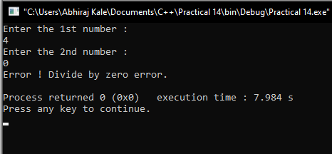

**CONCLUSION:**

**Thus we have successfully written a program to perform Exception Handling.**